Users and Groups Introduction User administration

Exercise

Q1. Create two groups(editor and author) and create users of each group.

Note: Editor would not have delete and replicate rights

Author would have all rights like administrators

Provide screenshots for questions

Ans. Editor Group:-

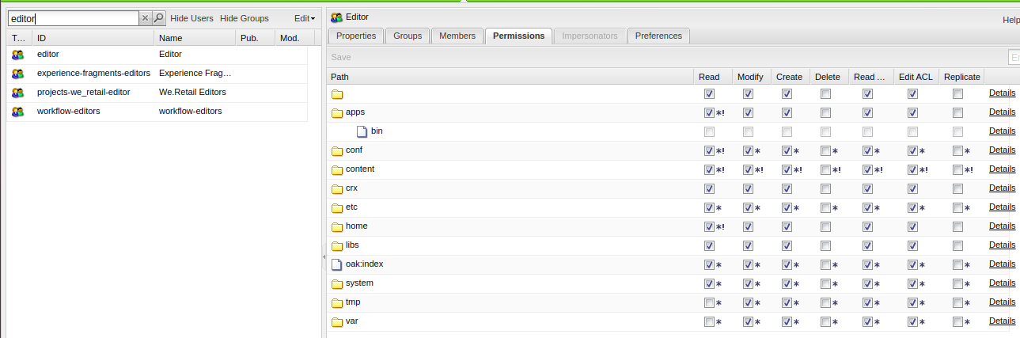

Author:-

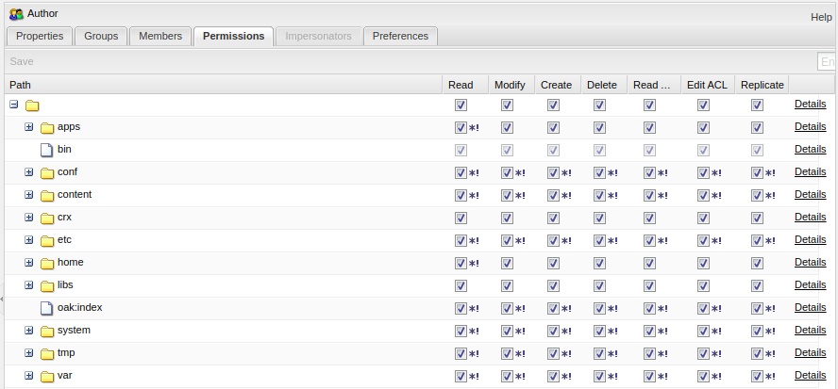

Editor user(ishika aulak):-

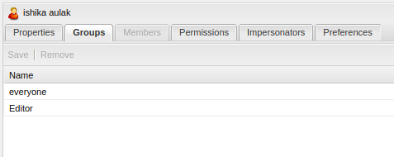

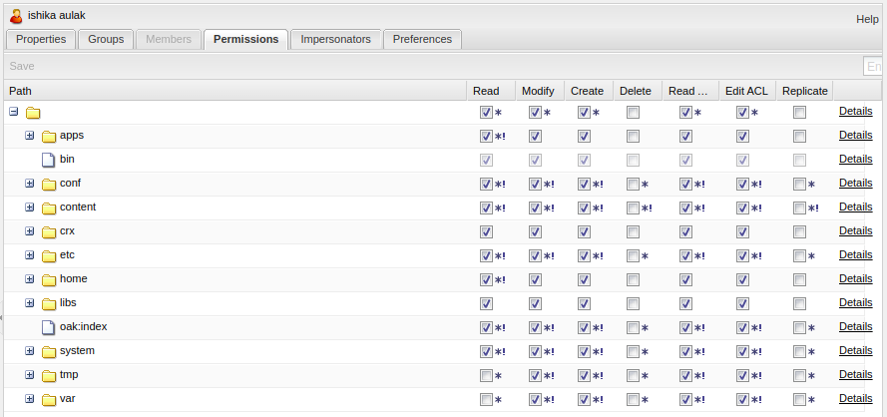

Author user(arpit aulak):-

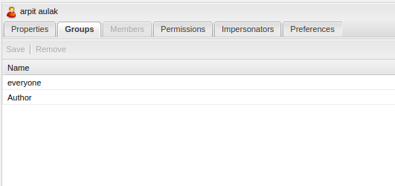

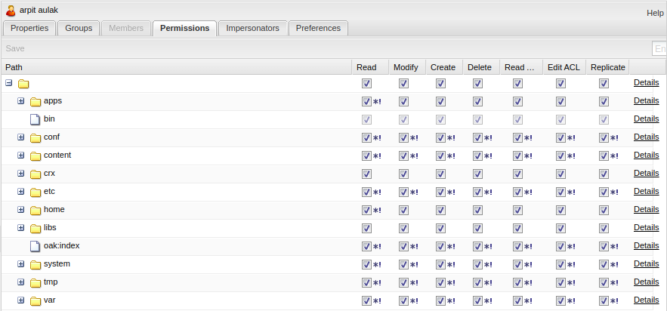

Q2. Impersonate a user of editor gp to author gp and test if you can replicate or delete the pages.

Note: Editor would not have delete and replicate rights

Author would have all rights like administrators

Provide screenshots for questions

Ans. first added editor user(ishika aulak) as impersonator in the author user(arpit aulak)

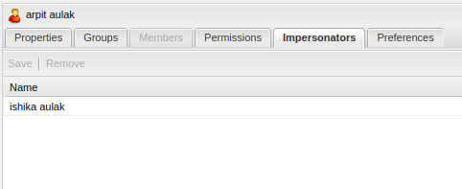

Then, logged in as editor user(ishika aulak) and impersonated as author user(arpit aulak).

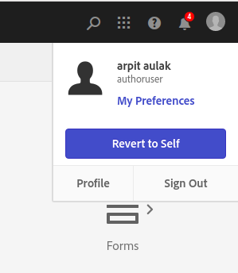

After that we can delete or replicate any page even though editor user don’t have the permissions for that:-

Deleted the page(page1):-

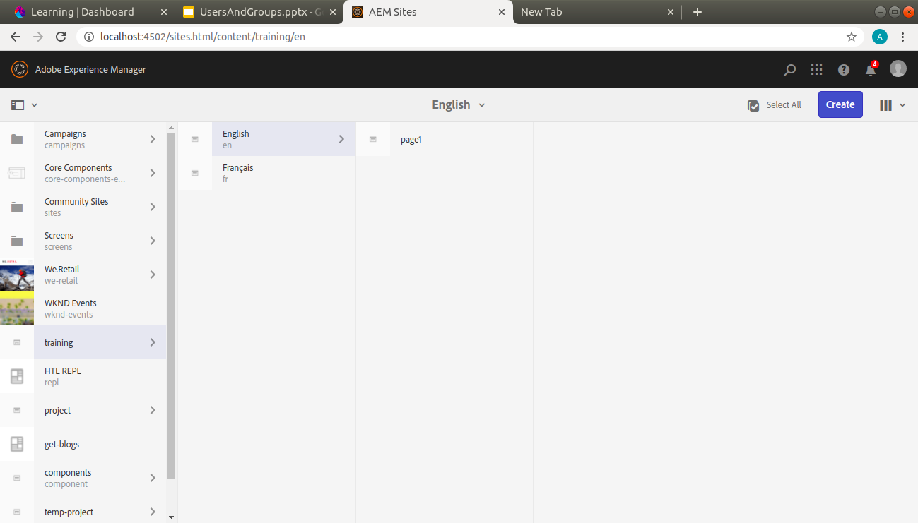

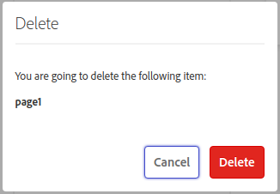

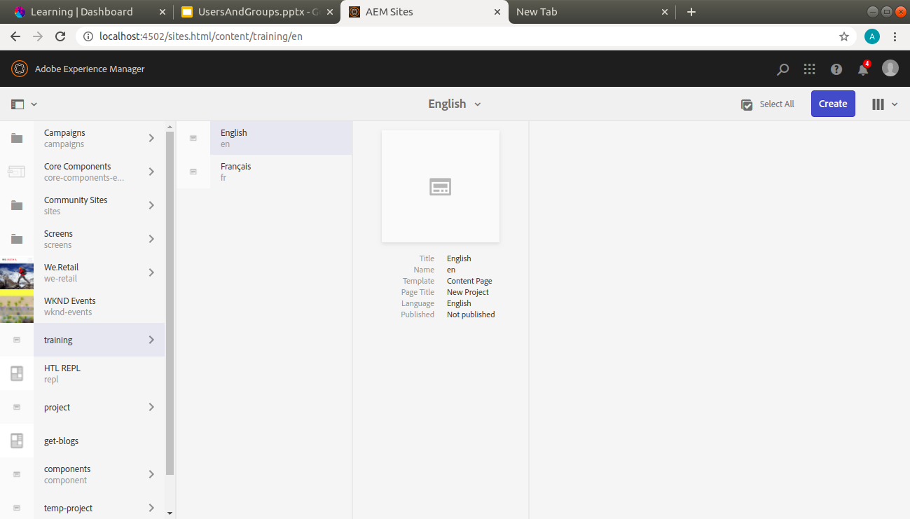

Copied the page English into francais:-

